Online Submittal Instructions for device test data
for the Zeeland Board of Public Works Cross Connection Program

All testing contractors must register with ZBPW to test backflow devices in Zeeland. Submit company info, tester name & test certification, and current year test gauge certification to lloydv@zeelandbpw.com . The web submittal of device test data is a simple process. You will enter the data on a web form and be prompted to submit the data once you are confident that the web form is complete. Once the data is submitted you will receive a confirmation email with an attached copy of the completed test form in pdf.
To begin, go to our website www.zeelandbpw.com. Under water, choose the Cross Connection page, submitt test results (you can bookmark our web site to your Internet favorites). You will then enter your user name and password (provided by ZBPW ) to log into our system (Figure 1). You will then be required to enter the seven digit location code for the facility where the tests were completed (Figure 2) or you can enter the serial number of a device located at the facility. Location codes are entirely alphabetical (no numbers are used). The facility’s test notification letter will have the location code and a list of backflow devices installed at the facility. If you are missing this code or the device serial number, please contact the facility owner or call ZBPW at 616-772-6212.
If you have a problem logging into the system, close your browser and start over from the “Submit test results” link on our Cross Connection page. Do not attempt to change your password as your passwords are managed by us.
Figure 1
Figure 2

You then will be asked to choose the assembly for which to enter the test results for (Figure 3). If the facility has more than one assembly installed you can choose from a list of assemblies. Be sure to test all assemblies at the facility or the facility will be flagged as non-compliant until we receive the competed test results for all assemblies.
Figure 3b
Figure 3a

You also have the option for replacing the existing assembly if the assembly was changed out (Figure 4). If a device was replaced do not enter a new device but choose replace the selected assembly or there will be duplicate devices for the facility. Be sure to fill in the details (including the new serial number) for the replaced assembly when you enter the test results on the web form for the replaced assembly.
Figure 4b
Figure 4a
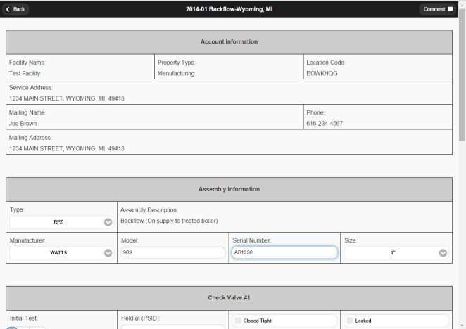

You can also choose add new if a new assembly was installed at the facility (Figure 5). Again be sure to fill in a description (include the location) for the new assembly and complete the details when you enter the test results on the web form for the new assembly.
Figure 5b
Figure 5a

When you click continue the test form will open and allow you to enter your test results. Use the fields for each intial test. NEW! For any device that fails the intial tests be sure to check the box (assembly failed) on the “Test Exceptions” section of the test form, (Figure 6a) use the comments field to note why the device failed. This will notify us that repairs are necessary and that the device will be retested in the future. (MDEQ requires us to track all failed devices).
Figure 6a

NEW! As in the past, a contractor cannot delete an assembly. If an assembly was removed check the box (assembly removed) on the “Test Exceptions” section of the test form, (Figure6b) use the comments field to note that the device was removed. This will notify us that we need to go out and verify why the device was removed.

Figure 6b

Make sure to complete all the fields including the pass/fail, closed/open, service restored, and gauge readings. Choose the tester if your company has multiple testers, the test gauged used (Figure 7) gauge certification must be current, enter the tester certification number, and sign the form (some notation must be in the signature box).

You must choose the test gauge used Test gauge certification must be current
Figure 7a
Figure 7b

Be sure to click save. If any information is missing you will be prompted to finish completing the form before you can save the form. You will be given one more opportunity to review the data before you submit the assembly test results. Submitting the form is final and it cannot be modified once it is submitted.
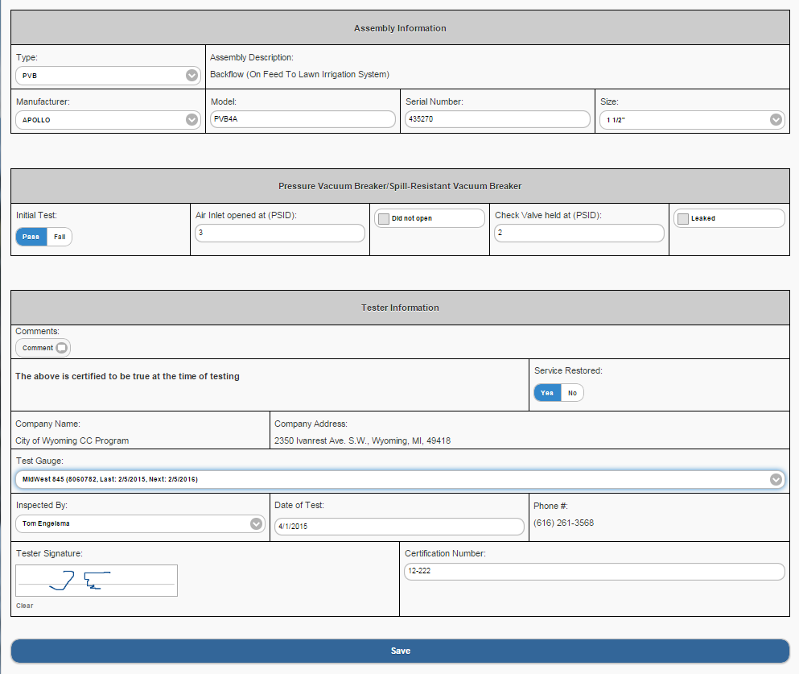

Zeeland Board of Public Works

Joe Brown

Just a reminder, be sure to enter all the test results accurately as the ZBPW will be reviewing your data. If you have any questions please call the ZBPW at 616-772-6212 or email lloydv@zeelandbpw.com.

Once the completed device test form is saved and the data submitted, you will receive an email confirmation (to the email address you submitted) which will include a PDF copy of the test results for for your records, see below.

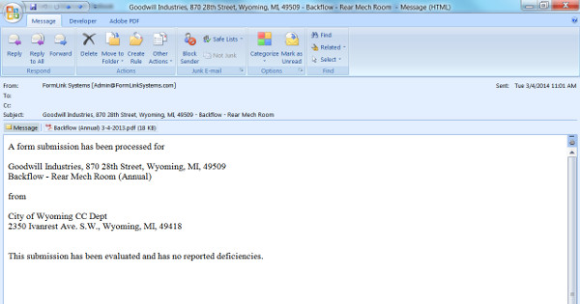
Zeeland Board of Public Works Cross Connection Department
Cross
