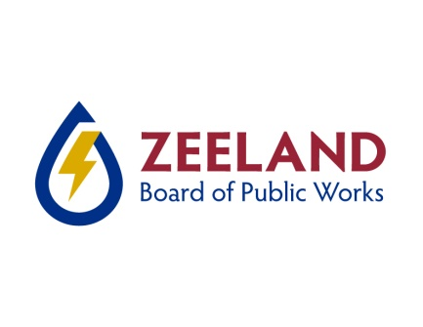Test Gauge Certification Companies

The Zeeland Board of Public Works Cross Connection program requires that all test gauges used for backflow assembly testing in Zeeland be annually certified for accuracy. If you are a new testing contractor we need your gauge certification for the current calendar year before we can issue login credentials for the web based test data entry using our web portal (we no longer accept faxed, emailed, or mailed test forms). Existing contractors, your gauge certification must be valid for the current calendar year or the software will not allow you to enter test data.

Following is a partial list of companies that provide test gauge certification services. This is not a complete list, is provided as a courtesy, and is not intended as an endorsement. The businesses listed below have no affiliation with ZBPW. Please return all gauge certification by email to: lloydv@zeelandbpw.com

Please call or email the Cross Connection Department if you have any questions, (616) 879-2407

Mid-West Instrument
6500 Dobry Dr
Sterling Heights, MI 48314
586-254-6509

Smith Instrument
Grand Rapids Office
3838 Clay Avenue S W
Wyoming, MI 49548
616-245-1195

Harrison Instrument
38777 Shoolcraft Rd.
Livonia, MI 48150
800-483-3292

Orange Research
140 Cascade Blvd
Milford, CN 06460
800-989-5657

Process Instruments
615 E Carson Street
Pittsburg, PA 15203-1021
412-431-3792

Gage-It Inc
94 N. Branch Street
Sellersville, PA 18960
800-869-7294

Macomb Group
Grand Rapids Office
3940 Clay Ave
Wyoming, MI 49548
616-531-9600

BAVCO
20453 S. Susana Rd.
Long Beach, CA 90810
800-458-3492

